**ER Diagram convert to Relational model**

ER diagram: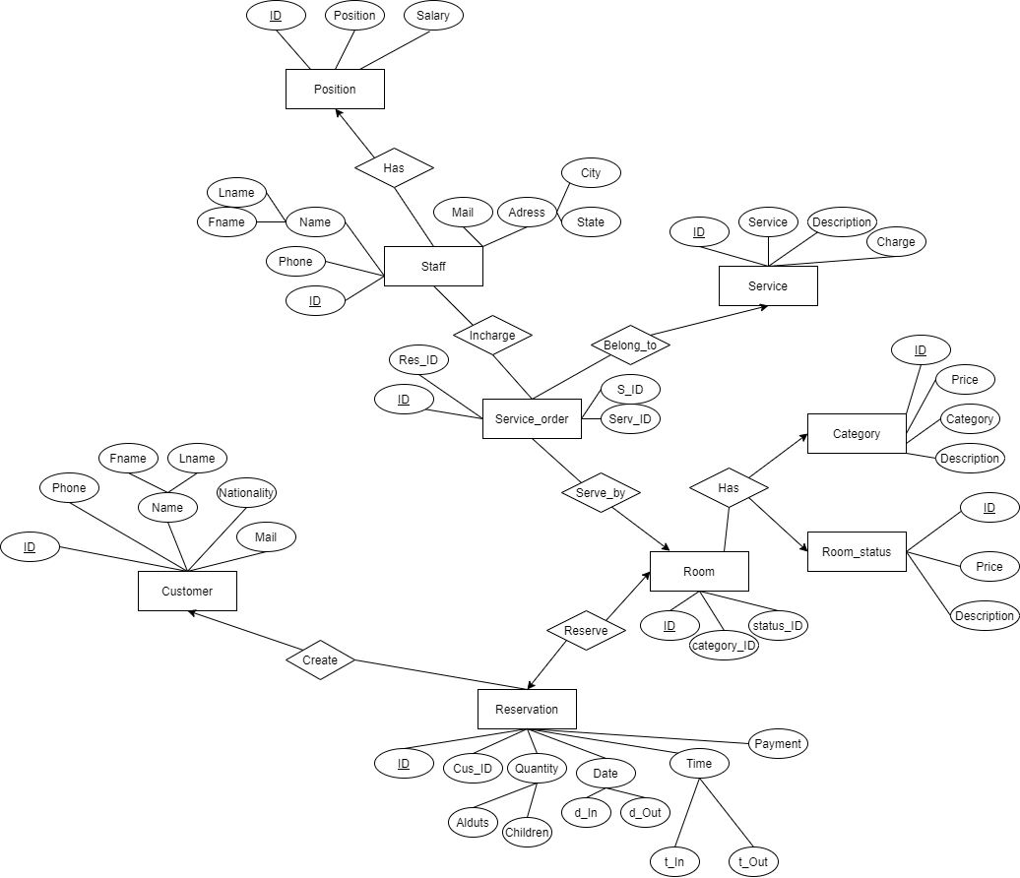

In this diagram, we can see there are total 9 strong entities:

Customer, Reservation, Room, Room_status, Category, Service_order, Service, Staff and Position

For these 9 entities we will have 9 tables with the same name

Let us convert all the entities into tables, one by one:

**1.Customer**

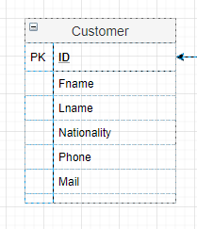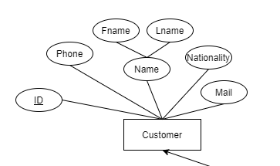

Schema: Customer (ID, Fname, Lname, Nationality, Phone, Mail)

This table contain the needed information of the customers

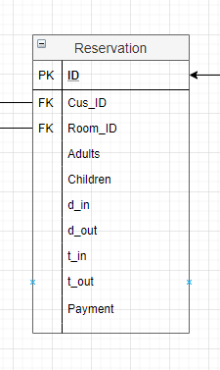

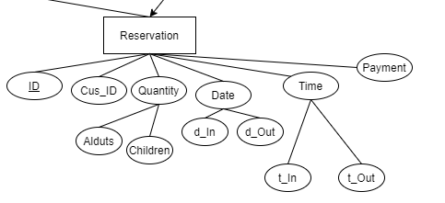**2.Reservation**

Schema: Reservatiom (ID, Cus_ID, Room_ID, Adults, Children, d_in, d_out, t_in, t_ out, Payment)

Cus_ID is a foreign key with references to Customer (ID)

Room_ID is a foreign key with references to Room (ID)

As a reservation must have the information of a customer and the room he/she has reserved

*each customer can make many reservations

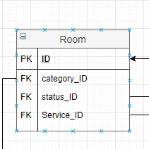**3.Room**

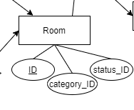

Schema: Room (ID, category_ID, Status_ID, Service_ID)

Category_ID is a foreign key with references to Category (ID)

Status_ID is a foreign key with references to Room_status (ID)

As there are many rooms belong to different categories and each room has their own status

Service_ID is a foreign key with references to Service_order (ID)

As the customer from a specific room can demand different services

**4.Category**

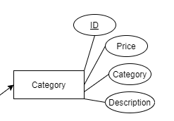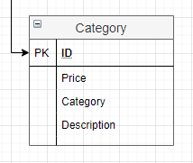

Schema: Category (ID, Price, Category, Description)

This table contain the price and description of room categories

*each category can have many rooms and each room can only belong to one category

**5.Room_status**

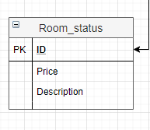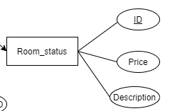

Schema: Room_status(ID, Price, Description)

This table contain the description of room statuses and the prices that the room status can affect beside the room category

*each room can only have one status at a time, the status will be frequently updated

**6.Service_order**

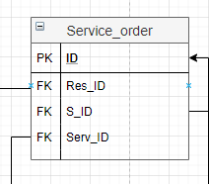

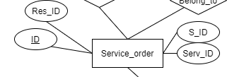

Schema: Service_order (ID, Res_ID, S_ID, Serv_ID)

Res_ID is a foreign key with references to Reservation (ID) which indicate the customer or room of the reservation that demanded the service

S_ID is a foreign key with references to Staff (ID) that will specify the staff who will do the service

Serv_ID is a foreign key with references to Service (ID) that indicate the type of service that need to be done

*each service order can have one service each and one staff do the servicing

**7.Service**

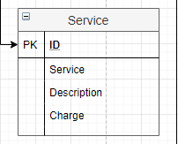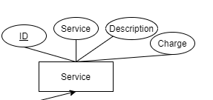

Schema: Service (ID, Service, Description, Charge)

This table contain information about types of service, their description and the charge

**8.Staff**

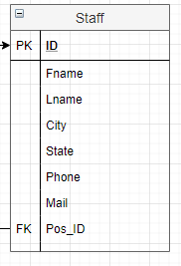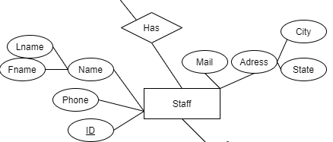

Schema: Staff (ID, Fname, Lname, City, State, Phone, Mail, Pos_ID)

Pos_ID is a foreign key with references to Position (ID) which indicate the job and position of the employee in the Hotel system

Each staff member can only have one position, this can be update

**9.Position**

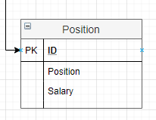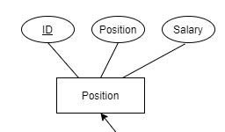

Schema: Position (ID, Position, Salary)

This table contain the position and the Salary of each job

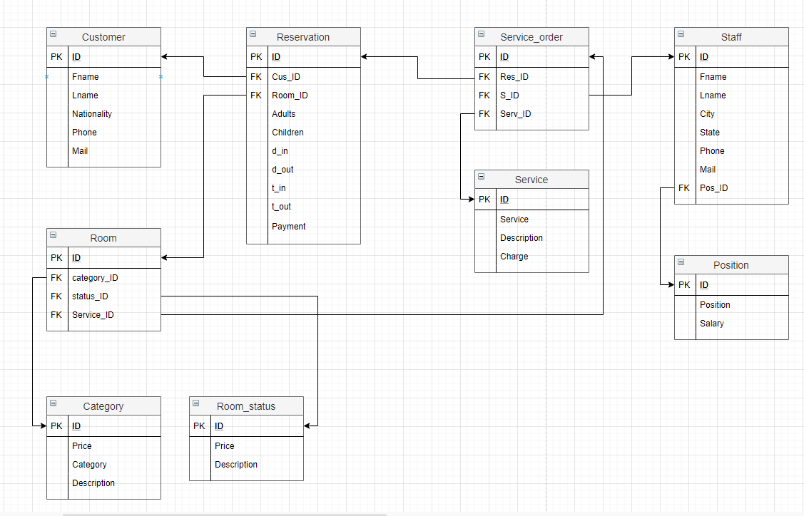**The final Relational model:**